LED STRIP SMD5050 96LED/M IP20
96灯/米 不防水灯带 5050RGBWNW系列

Customer Name/客户名称：
Standard Model/规格型号： LNTS5RGBWNW96N4-M1-D24-12P
Product description /产品描述： SMD5050 RGBWNW 12mm 24V灯带

CUSTOMER/客户
CONFIRMER  设计/开发/采购 | CHECKER  审核 | APPROVER  批准

SUPPLIER/供货商
拟制  FICTION | 审核  CHECKER | 批准  APPROVER
黄华波

PRODUCT PICTURE产品图片

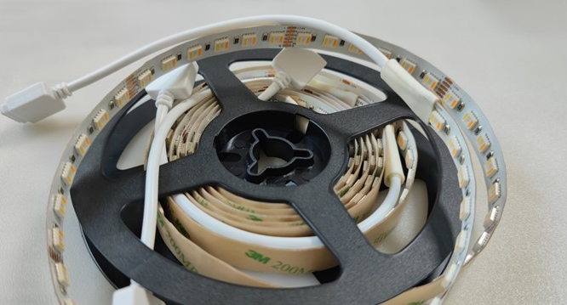

Features 特点

※光效高、温升低；
※高显值、高亮度；
※具有良好的线性效果，可取代传统的光源；
※良好的衰减功能，使用寿命长，耐弯折性好；
※产品设有可剪位，也可根据客户需求定制；

※High light efficiency, low temperature;
※High CRI, High brightness;
※It has good linear effect and can replace the traditional light source;
※Good attenuation function, long service life and good bending resistance;
※Products can be cut position, can also be customized according to customer needs；

Minimum bending radius 最小弯曲半径

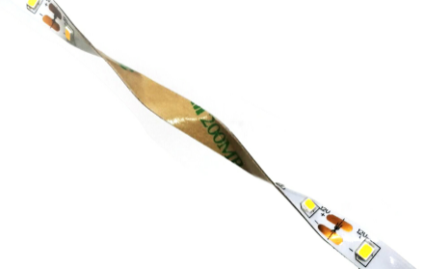
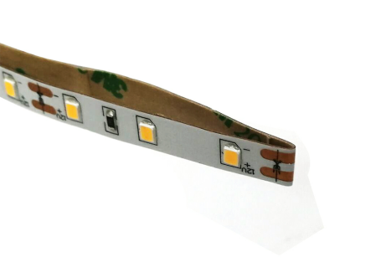

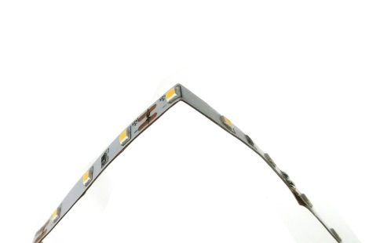
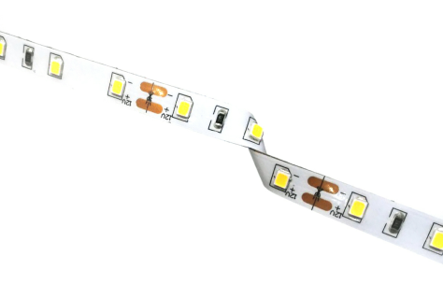

最小弯曲半径R_{min}=30mm

Parameter基本参数

Model 型 号： | LNTS5RGBWNW96N4-M1-D24-12P |  |  | Luminous flux光通量： |  |  | R:220±10%lm/m  G:480±10%lm/m  B:100±10%lm/m  WW:480±10%lm/m  PW:530±10%lm/m
Rated power功 率： | R:6.8W /m±10%  G:6.7W /m±10%  B:6.5W /m±10%  WW:6.7W /m±10%  PW:6.8W /m±10% |  |  | Efficiency光效值： |  |  | R: 32±10%lm /W  G: 72±10%lm /W  B:15±10%lm/W  WW: 72±10%lm /W  PW: 78±10%lm /W
Total power总功率： | 41.95W±10% (2m) |  |  | Beam angle发光角度： |  |  | 120°
Input voltage电压： | DC24V |  |  | Optimum length首尾无亮差： |  |  | 3m
LED type灯珠类型： | SMD5050 96LED/M |  |  | Cutting Unit最小剪裁单位： |  |  | 62.5mm
Color 色温/波长： | R:620-625NM G:520-525NM B:465-470NM WW:2700±100K PW:6000±300K |  |  | IP rate防水等级： |  |  | IP20
Color 色温/波长： |  |  |  | Working temp工作温度： |  |  | -20℃~40℃
Adhesive  胶 系 |  | Serial number  产品编号 | Material  基材 | High temperature resistant 耐高温℃ |  | Solvent Resistance抗溶剂性 |  | Relative viscosity  相对粘性
 |  | Serial number  产品编号 | Material  基材 | Short Time短期 | Long Time长期 |  |  | HSE | LSE
300LSE Double faced adhesive tape 300LSE双面胶 |  | 9495LSE | PET | 140 | 120 | Middle中 |  | High高 | High高
Application用途 |  | Suitable for low surface energy bonding, excellent adhesion properties on plastics, foams and cushion materials.适用于低表面能粘接，对低表面能的塑料、泡棉及软垫材料的粘接性能优异。
备注：
①.The test environment temperature is 25 ± 2 ℃;测试环境温度为 25±2℃；
②.The above parameters correspond to specific samples, and the change of raw material parameters will cause
fluctuations;以上参数对应特定样品，更改原材料参数会出现波动；
③.The values of the parameters are typical values, and there are some errors in the normal range with the actual
parameters of the samples.参数数值为典型值，与样品实际参数有一定正常范围内的误差。
④.This product is guaranteed for 3 years，If you have any other questions, please contact the sales staff.
本产品的质保期为3年，如有其它疑问，请联系销售人员联系。
Drawings 尺寸图

Unit单位：mm

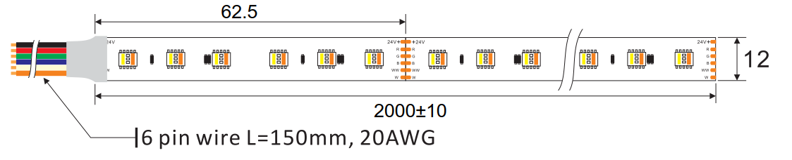

parameters of different length light strips不同长度灯条典型光电参数
 | 参 数
Length of strip灯条长度 | 1m | 2m | \ | \ | \
Working voltage工作电压(V) | DC 24V | DC 24V | \ | \ | \
Total current总电流(A) | 1.32 | 1.748 | \ | \ | \
Total power总功率(W) | 31.68 | 41.95 | \ | \ | \
Head voltage首端电压(V) | 23.99 | 23.99 | \ | \ | \
End voltage尾端电压(V) | 23.74 | 23.29 | \ | \ | \
Voltage decay rate首尾压衰率（%） | 1.04 | 2.92 | \ | \ | \
Power supply单/双端供电 | single end  单端 | single end  单端 | \ | \ | \

Light distribution样品配光曲线

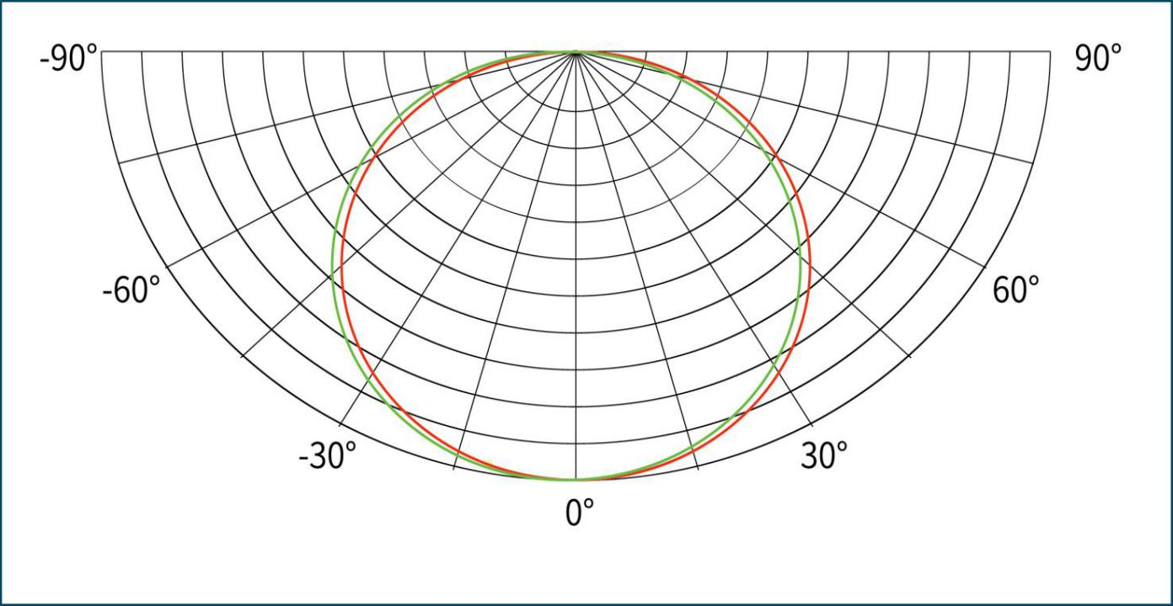
30

60

90

120

150
180
光 强 ：cd
C0/180,116.1°
C90/270,116.8°

平均光束角度(50%)：116.3度

Note: the above is the test result when the lamp color temperature is RGBWNW. If you have any other questions,
please contact the sales staff.
备注：以上是灯珠色温RGBWNW时测试所得，如有其他疑问，请联系销售人员联系。

Simple Connection Steps免焊连接器接灯条示意图

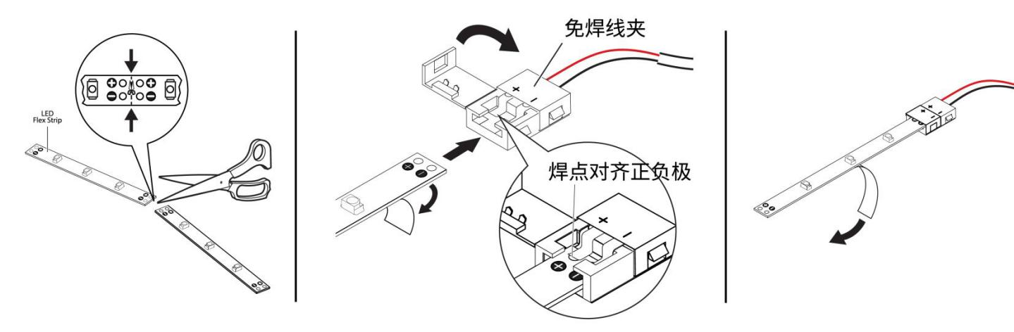
按照灯条上裁剪标识剪裁所需要的长度。
Cut along the light strip tape
wherever a dashed line divides
two sets of positive and negative connection points.

将灯条卡入免焊夹中。再合上铰链夹。
Peel away a portion of the light strip adhesive
backing at one end. With the solderless clamp
open, slide the strip end all the way into the
solderless clamp. Close the hinged clamp.

撕下双面胶把灯条粘贴在所需位置表面，再连接电源。
Remove the remaining adhesive
backing and attach the light strip
to the desired surface.

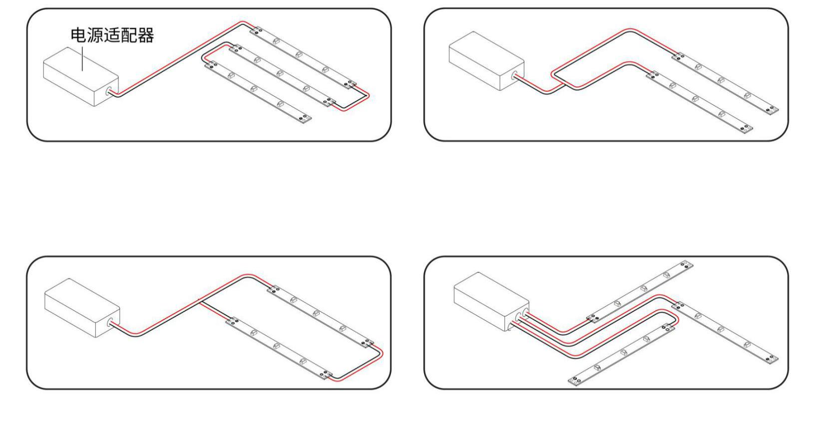
①Light strips are powered in a continuous ‘Straight’ run. Strips that are furthest from the power supply are more likely to exhibit voltage drop.
灯条连续‘直线’接线。离电源最远的灯条更有可能出现压降现象。
②Light strips are powered from a spliced‘Centerfeed’connection. This type of layout tends to produce more consistent brightness and color between strips.
灯带‘并联’再连接电源。这种接线方式更有利于在条带点亮后拥有一致的亮度和颜色。
③Light strips are powered from a single looped ‘Loopback’ connection, which also produces more consistent results. Often used for room perimeter and cove
灯条由单环‘回圈’连接供电，灯条点亮后颜色和亮度一致性更好。常用于房间周边和凹处布局。
④In the ‘Array’ option, light strip ‘legs’ are individually powered. Total wattage should be determined so as not to overload power supply.
‘阵列’接线，灯条是单独供电的。这种接线方式应确定总瓦数，以便不要让电源过载。
Common wiring diagram常见接线示意以及说明

Product fault reference table产品简单问题故障速查表
Fault phenomenon  故障现象 | Possible reason  可能原因 | Solution  解决方法
All the led are off  所有LED不亮 | 1.No electricity 市电没供电 | Power transmission送电
All the led are off  所有LED不亮 | - Short /open circuit  电源输出端开路或短路， 引起电源自动保护 | Check the circuit and remove the fault  排除故障，重新送电
All the led are off  所有LED不亮 | - The polarity is reversed  产品供电端极性接反 | Check the circuit and remove the fault  排除故障，重新送电
Some LEDs are off  部分LED不亮 | - Some power supply not powered  部分电源没有供电 | Check the power circuit and remove the fault  检查供电系统，排除故障
Some LEDs are off  部分LED不亮 | - Some products's circuit is wrong  部分产品供电电路出错 | Check the power circuit and remove the fault  检查供电系统，排除故障
Some LEDs are off  部分LED不亮 | - Some products'polarity is reversed  个别产品极性接反 | Connect the wires correctly  正确接线
Led Uneven brightness or low brightness  LED亮度不均或亮度不够 | - Power overload  电源超负荷 | Increase the power load  增大电源负荷量
Led Uneven brightness or low brightness  LED亮度不均或亮度不够 | - Power consumption overload  电源输出端损耗过大 | Ensure that the product operating voltage error is within ±5% of the standard确保产品工作电压误差在标准电压的±5%以内，或保持电路各支路损耗保持平均
LED Flashing  LED闪烁 | - terminal not be connected correctly  接线点接触不良 | Identify the fault point and remove the fault  找出故障点，排除故障
LED Flashing  LED闪烁 | - Power supply failure  电源故障 | Ensure the working voltage error is within the standard voltage  确保产品工作电压误差在标准电压
LED Flashing  LED闪烁 | - Products not used as required  未按要求使用产品 | Make sure to follow the product instructions to use the product确保遵照产品说明使用产品

Installation notes 注意事项

※使用的电源和负载的电压、电流、功率必须与本产品相符。
※严禁拆卸或修改此灯，灯珠表面禁止锐物触碰。
※使用中性玻璃胶固定产品时，须在宽敞并空气流通的环境中待胶体固化4小时以上，再进行封闭。
※请按接线图正确接线（先接负载再接电源，或送电）操作过程中注意避免短路。
※对于直条形不防水软条，超过最大级联长度，必须进行错位补电。
※对于直条形不防水软条，如果单灯珠超过常规电流使用，请增添辅助散热。
※电源和产品间的电源连线不能过长，如无特殊规定，一般为2米长， 否则线损增大，导致产品首尾端亮度不一致。
※安装、维修、保养必须是专业人员作业，严禁非专业人员作业。

※Before installation, please check whether all of the parameters of the product are consistent with the requirements (refer to the product specifications ). The working voltage, current and power of the power supply must be consistent with this product.
※It is strictly forbidden to disassemble or modify this product, and the surface of the led is forbidden to touch with
sharp objects. During the installation process, Live operation is strictly prohibited.
※When fixing the product with neutral glass glue, the glue should be cured for more than 4 hours in a spacious and airy environment before being closed.
※Please follow the instruction for correct wiring to avoid short circuit during operation.
※For led strips, if the maximum cascade length is exceeded, it is necessary to perform offset electric charging.
※For led strips, if a single led exceeds the normal current, please add auxiliary heat dissipation.
※Installation, repair and maintenance must be performed by qualified electrician.

